Experiment:11
Implementation of IoT-based Smart Agriculture using MATLAB
P. VENKATA KISHORE
192412581
OBJECTIVE:1:
To monitor the Soil Moisture (%) level in agricultural fields using IoT-based sensing simulation in MATLAB.
MATLAB CODE:
clc; clear; close all;
% Simulated soil moisture data (%)
time = 1:10;
soil_moisture = [30 35 28 25 20 18 22 30 40 45];
% Threshold for irrigation
threshold = 40;
figure
% -------- Graph 1: Soil Moisture Variation --------
subplot(2,1,1)
plot(time, soil_moisture, '-o', 'LineWidth', 2)
title('Soil Moisture Monitoring in IoT Smart Agriculture')
xlabel('Time (Hours)')
ylabel('Soil Moisture (%)')
grid on
hold on
yline(threshold,'r--','Threshold')
% -------- Graph 2: Moisture Status (Dry/Wet Level) --------
status = soil_moisture >= threshold;
subplot(2,1,2)
stem(time, status, 'filled', 'LineWidth', 2)
title('Soil Condition Status (1=Wet, 0=Dry)')
xlabel('Time (Hours)')
ylabel('Status')
grid on

OUTPUT:

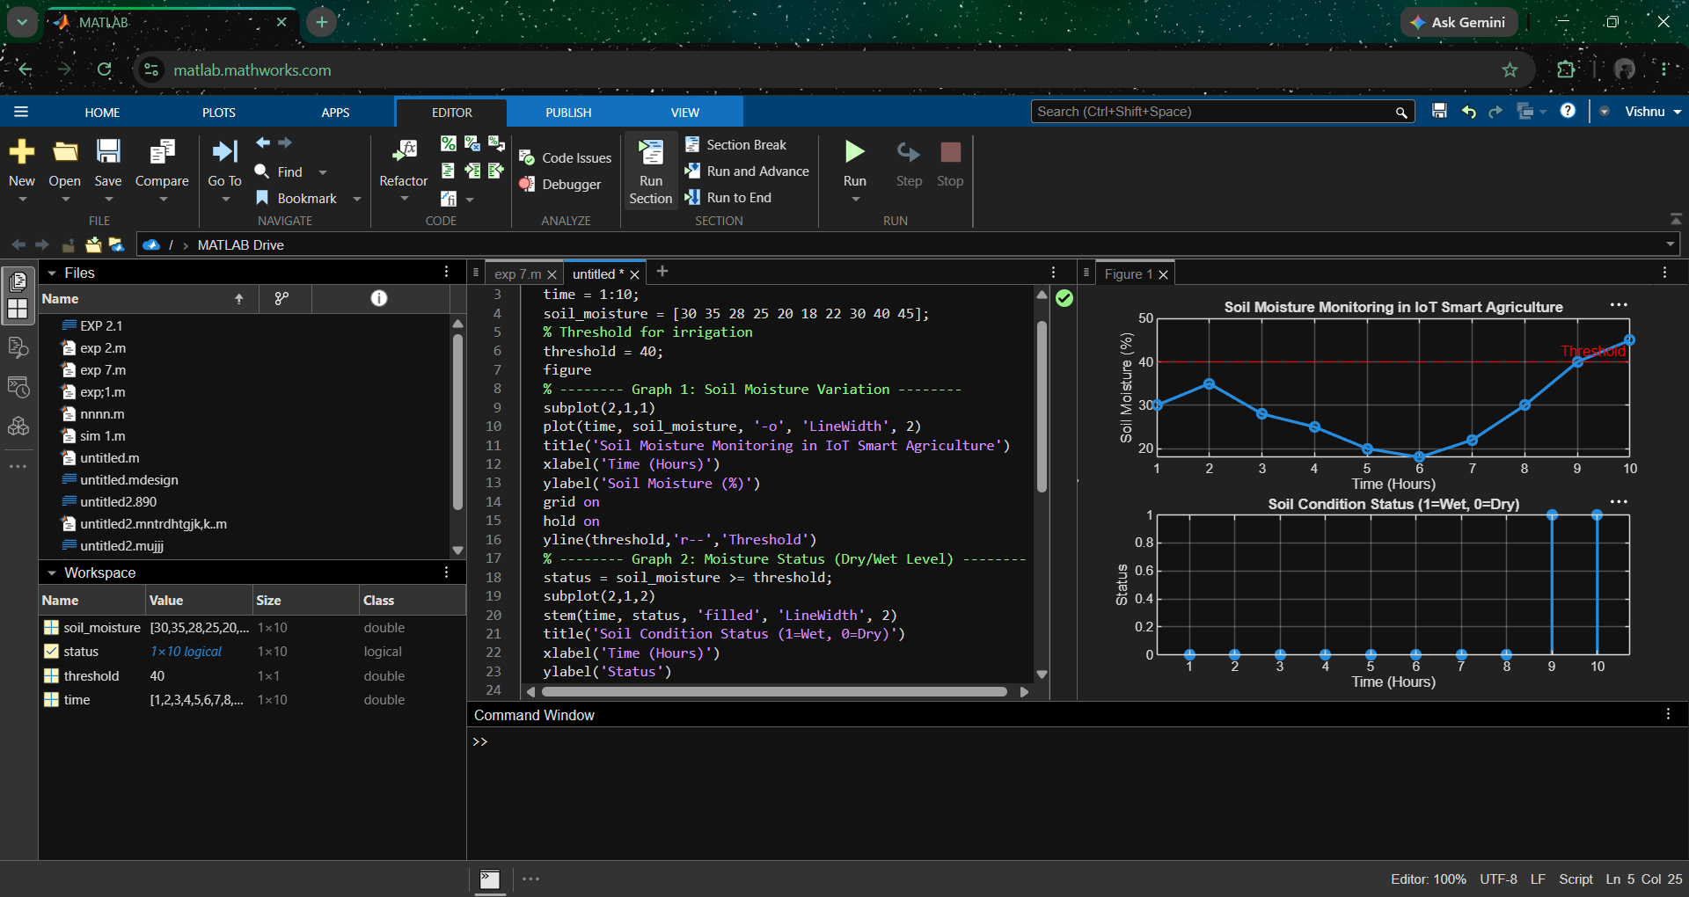

OBJECTIVE:2:
To control and display the Water Pump Status (ON/OFF) based on threshold soil moisture conditions.
MATLAB CODE:
clc; clear; close all;
% Simulated soil moisture (%)
time = 1:10;
soil_moisture = [30 35 28 25 20 18 22 30 40 45];
% Threshold level
threshold = 40;
% Pump control logic (1 = ON, 0 = OFF)
pump_status = soil_moisture < threshold;
figure
% -------- Graph 1: Soil Moisture vs Pump Status --------
subplot(2,1,1)
plot(time, soil_moisture, '-o','LineWidth',2)
title('Soil Moisture vs Pump Control')
xlabel('Time (Hours)')
ylabel('Soil Moisture (%)')
grid on
hold on
yline(threshold,'r--','Threshold')
% -------- Graph 2: Pump Status (ON/OFF) --------
subplot(2,1,2)
stem(time, pump_status, 'filled','LineWidth',2)
title('Water Pump Status (1=ON, 0=OFF)')
xlabel('Time (Hours)')
ylabel('Pump Status')
grid on

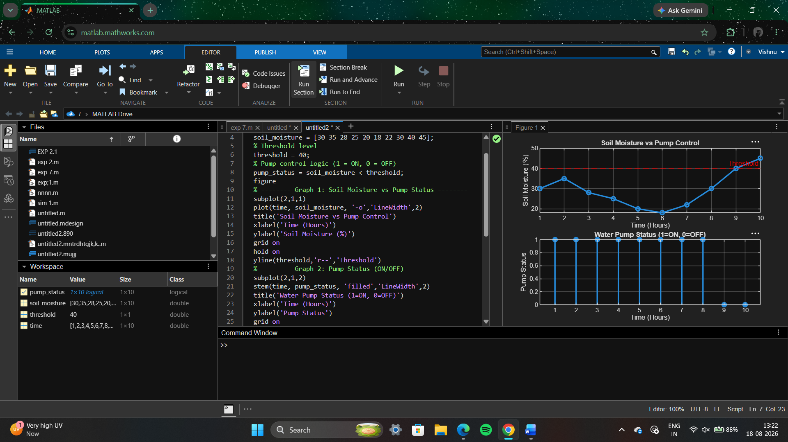

OBJECTIVE:3:
To evaluate the Irrigation Efficiency (%) by analyzing water usage effectiveness and moisture maintenance level.
MATLAB CODE:

clc; clear; close all;
% Simulated soil moisture data (%)
time = 1:10;
soil_moisture = [30 35 28 25 20 18 22 30 40 45];
% Threshold level
threshold = 40;
% Irrigation efficiency calculation (%)
efficiency = (soil_moisture ./ threshold) * 100;
efficiency(efficiency > 100) = 100; % limit to 100%
figure
% -------- Graph 1: Soil Moisture vs Efficiency --------
subplot(2,1,1)
plot(time, soil_moisture, '-o','LineWidth',2)
title('Soil Moisture Variation')
xlabel('Time (Hours)')
ylabel('Soil Moisture (%)')
grid on
hold on
yline(threshold,'r--','Threshold')
% -------- Graph 2: Irrigation Efficiency --------
subplot(2,1,2)
plot(time, efficiency, '-s','LineWidth',2)
title('Irrigation Efficiency (%) in Smart Agriculture')
xlabel('Time (Hours)')
ylabel('Efficiency (%)')
grid on
OUTPUT:

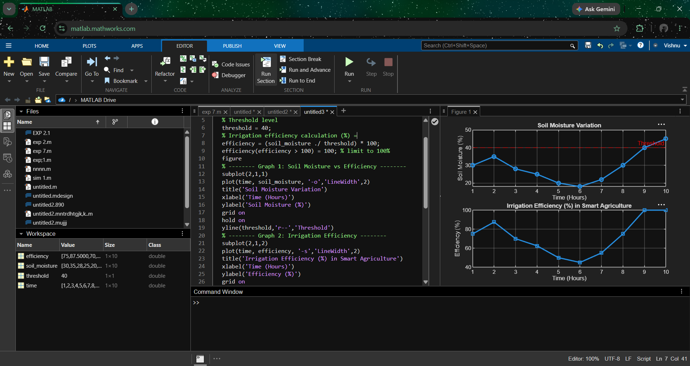

Result :
1. The soil moisture levels were successfully monitored using MATLAB simulation, showing variation over time and identifying dry and wet conditions based on threshold values.
2. The water pump control system was effectively implemented, where the pump automatically switched ON when soil moisture dropped below the threshold and remained OFF when moisture was sufficient.
3. The irrigation efficiency was successfully calculated and analyzed, showing that the system optimizes water usage by maintaining soil moisture close to the desired level.

